

# ELEC S212

**Network Programming and Design**

## 2018 Autumn Presentation

**Assignment 2**

Please e-submit this assignment via the OLE

### by 27 Jan 2019, 23:59

DON’T GIVE UP!!

I am sure you will progress. Please feel free to contact me for programming issues.

You have shown WEAK understanding on C-programming & debugging, C-compilation model, socket programming concept, network application using cgi, how to publish web page and cgi script to web server.

If you more support, please feel free to contact me.

You are suggested to enhance:

1. Read and understand question before answer
2. Meaning/Function of source file, preprocessor, linker, object code and object file, executable file, header file and library.

How to create bug-free executable ConsoleToFile

1. How to debug C program

There are same type of bugs in line 1 and 2. Think about quotation symbol for the header filename. Note that this error is gcc-implementation specific. Please refer to <http://www.acm.uiuc.edu/webmonkeys/book/c_guide/1.7.html#include>

* There is a bug in line 29. Is outputFile a pointer to the filename (i.e. a pointer to a string)? Should it be a filename?

1. Technologies/Programming languages to provide dynamic web page.
2. Understand input string to CGI program.
3. Each C string ends with ‘\0’ character
4. How to use atoi()
5. How to modify getInput() function of CGI program based on requirement
6. How to write c program to count the frequency of a certain key pattern in a given database.
7. How to modify c program, which counts the frequency of a certain key pattern in a given database, into CIA program.
8. How to use data structure in C to display input date in American format date

* Cannot handle leap year.
* Cannot handle when input date is NOT valid.
* comment can be enhanced

1. How to create and close socket?
2. The connection-oriented client needs to resolve server’s hostname to IP address using gethostbyname() before connecting to server.
3. Why bind() is always required for both stream and datagram server but client side is NOT?
4. How to write a C program to convert hostname to IP address using gethostbyname()

8 marks.

**(Q1a)**

|  |  |  |
| --- | --- | --- |
| Terms | Meaning | Example |
| Source files | Source code file ends of .c extension, it’s include all execution code, such as header, data type, function, and so on. | File.c |
| Preprocessor | An instruction to pc to do something before compiling the source code, identified by the presence of #. | #include<studio.h>  Anything starts with # will be preprocessed before sending it to compiler. |
| Compiler | Written in programming language (C/Java) will translate to machine code. | Gcc file.c |
| Assembler | Assembler is a low-level language, takes basic computer instructions and converts to binary. Directly control the operation of CPU. | Add a and b  Push 2  Add %ebx |
| Linker | Get the program into a final form for execution on the computer. | Executable object (a.out) |
| Object code and object files | Object code/file is the output of a compiler after it processes source code. | Printf(“hello,world”); |
| Executable file | An executable file (exe) is a computer file that contains an encoded sequence of instructions that the system can execute directly when the user clicks the file icon. | A.out is the default file extension for executable code |
| Header files and libraries | Header files define information about some of the functions that are provided by that file. | Stdio.h(standard input/output), is the standard C library header and provides functionality for displaying output, and many other things. We need to include this file in a program when using the printf()/scanf() function from the standard library. |

1. The following program contains **5 errors (bugs)**.



int main(void)

{

FILE outputFile; char file_name[]; int ch;

printf("This program saves your console input to an output file.\n"); printf("Enter the name of the output file: ");

scanf("%s", file_name); flush_input_buffer();

if (outputFile = fopen(file_name, "w") == NULL) { printf("Cannot open %s for writing.\n", file_name); return EXIT_FAILURE;

}

printf("Enter your input (Press Ctrl-D when done) ...\n"); while ((ch = getc(stdin)) != EOF) ; {

putc(ch, outputFile);

}

fclose(outputFile);

printf("===== Ctrl-D pressed ===== \n"); printf("Input saved to file %s\n", outputFile);

#include stdio.h

#include stdlib.h

1

2

3

4

5

6

7

8

9

10

11

12

13

14

15

16

17

18

19

20

21

22

23

24

25

26

27

28

29

30



31 return EXIT_SUCCESS;

32 }

33

1. void flush_input_buffer() {
2. while (getchar() != '\n') {
3. continue; 37 }

38 }

The following figure shows an example run of the correct program.

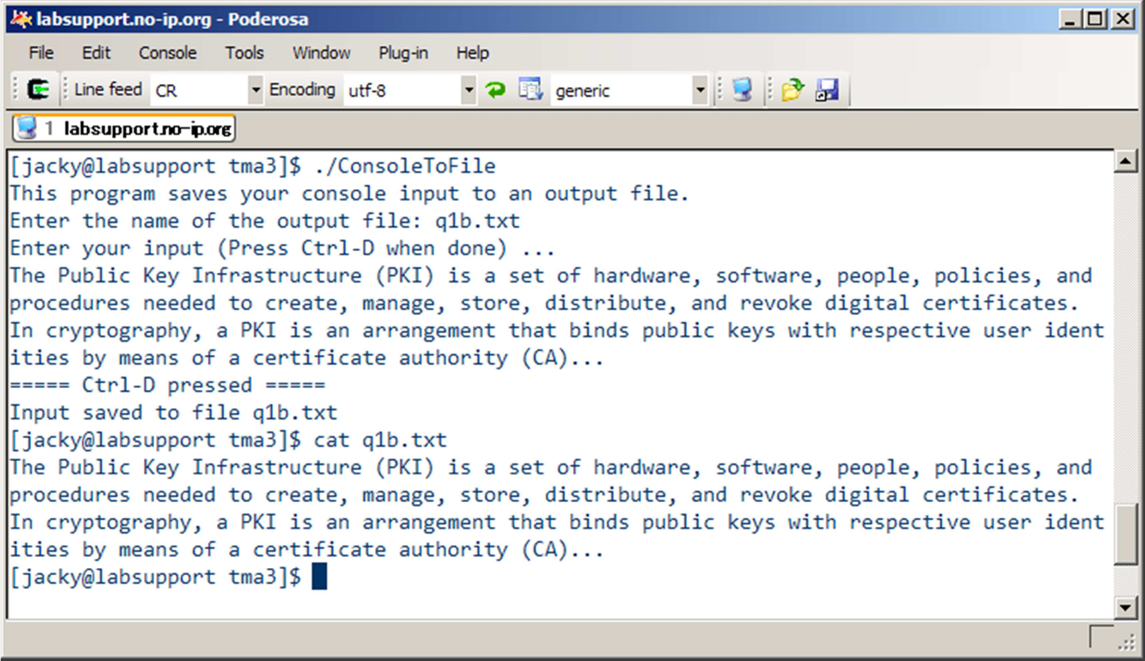

5.5 marks.

# B

# (1)

**Code:**



int main(void)

{

FILE outputFile; char file_name[]; int ch;

printf("This program saves your console input to an output file.\n"); printf("Enter the name of the output file: ");

scanf("%s", file_name); flush_input_buffer();

if (outputFile = fopen(file_name, "w") == NULL) { printf("Cannot open %s for writing.\n", file_name); return EXIT_FAILURE;

}

printf("Enter your input (Press Ctrl-D when done) ...\n"); while ((ch = getc(stdin)) != EOF) ; {

putc(ch, outputFile);

}

fclose(outputFile);

printf("===== Ctrl-D pressed ===== \n"); printf("Input saved to file %s\n", outputFile);

#include stdio.h

#include stdlib.h

1

2

3

4

5

6

7

8

9

10

11

12

13

14

15

16

17

18

19

20

21

22

23

24

25

26

27

28

29

30



31 return EXIT_SUCCESS;

32 }

33

1. void flush_input_buffer() {
2. while (getchar() != '\n') {
3. continue; 37 }

38 }

|  |  |  |
| --- | --- | --- |
| line | Why they are errors | How they should be correct |
| 7 | Definition of variable with array type needs an explicit size or an initializer. | For example, Char filename[100];  It provide the enough character to store the file name. |
| 15 | if (outputFile = fopen(file_name, "w") == NULL)  Incompatible integer to pointer conversion assigning to 'FILE * | **Change the program code.**  outputFile = fopen(file_name,"w");  if(outputFile == NULL){  printf("Cannot open %s for writing. \n",file_name);  return EXIT_FAILURE;  } |
| 17,31 | Return EXIT_FAILURE & EXIT_SUCCEUSS.  Use of undeclared identifier function. | #include <stdlib.h> |
| 22 | while ((ch = getc(stdin)) != EOF) ; {  while loop has empty body | Delete the “;”  While ((ch=getc(stdin))!=EOF{ |
| 34 | void flush_input_buffer()  Implicit declaration of function ‘flush_input_buffer’ is invalid | put the method (flush_input_buffer() )before call the method.  For example, put the method before **line 4** (main method), flush_input_buffer() |

**b2)**

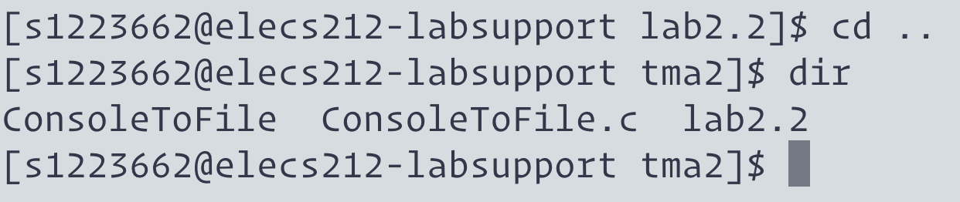

5.5 marks.

### Question 2a

### Step 1:

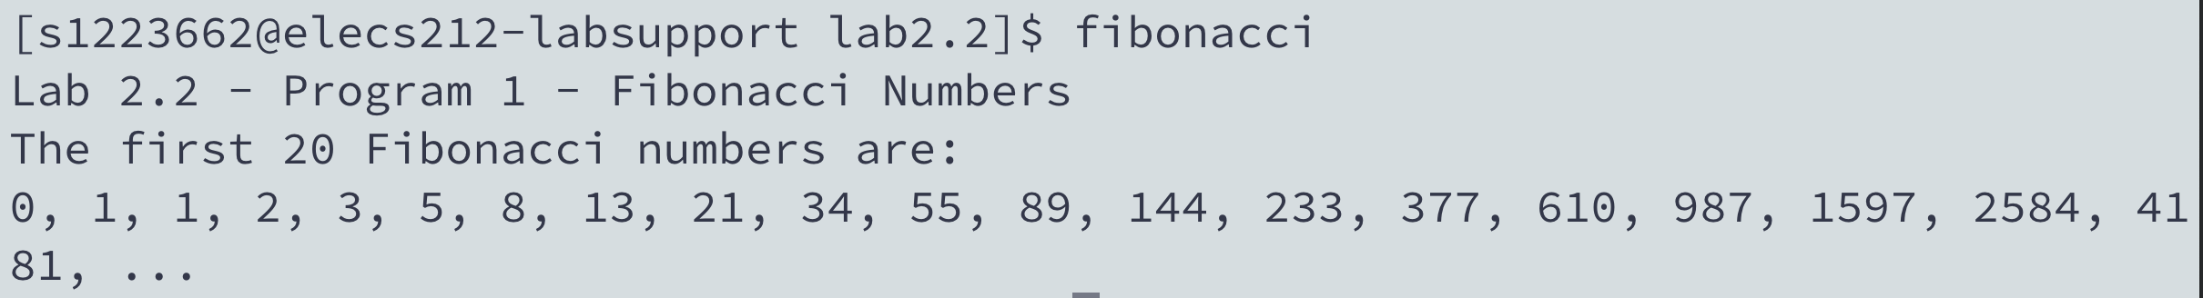

#### Step 2:

#### 

#### 

#### Step 3:

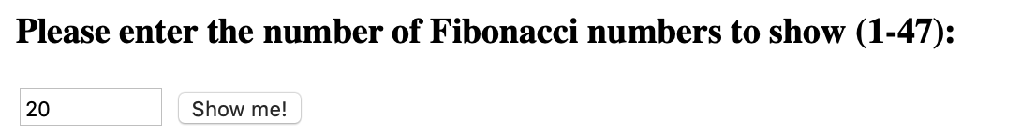



6.5 marks.

**Question 2(b)**

|  |
| --- |
| Q1  CGI is the interface between browser and Web server for transferring form input data to the CGI program.  The CGI application include any programming language, such as Perl,C/**C++,** Java.  **Perl:** Perl has been described as a compiled scripting language. It combines elements of C with some UNIX scripting and text manipulation languages into a more complete language. Perl’s advocates claim it is easy to use, especially compared to Java. One of the motivations in developing Perl was to provide an alternative to C for tasks that were a little too difficult for an existing UNIX tool, or where performance was a problem. C was seen as unnecessarily low level, and C development too time-consuming. Perl tries to delay the need to program at a lower level. It’s been very successful, especially among system administrators.  C/C++: C++ is an updated evolution of C that uses an object-oriented approach to programming. An object is anything that is addressed by the program as an entity with properties, attributes and rules that the program must follow in order to use the object.  Java:  Java is aggressively distributed and promoted by Sun Microsystems, which developed it, and, evidently, sees it as a way to loosen Microsoft’s and Intel’s grip on the computer platform. All major Web browsers now support the Java VM, and Java applets can be found on many websites. The ability to deliver a platform independent application, or, more correctly, an OS-independent application, is greatly appealing to developers, who spend a large portion of their resources developing and maintaining versions of their products for the different hardware/software platform combinations. |
| Q2  The commonly used to provide dynamic Web content is Active Server Page (ASP.NET), which is a script embedded in a web page is executed at the server before the page is sent which build the website dynamically.  Why ASP.NET is so popular?  CGI all involve programs that run on the server, usually tailoring a page for the user.  ASP.NET support different programming languages, such as C++, C#, Visual Basic and Parl.  Another programming language PHP is also very suited for dynamic webpages. It generally runs on a web server, which is configured to take PHP code as input and create webpage content as output. It can be deployed on most Web servers and on almost every operating system and platform free of charge. |
| Q3  The question requires: “Fibonacci number (1-47)”  Char input [9] means first 9 number, including  1,1,2,3,5,8,13,21,34  If char input[10], means first 10 numbers, 1,1,2,3,5,8,13,21,34,55.  55>50, therefore, we cannot use a larger array, but we still can use a smaller array to hold the data passed in. |
| Q4  What does input + 6 mean?  atoi() is to convert a “numeric string” to a integer value.  Atoi(input+6) means skips the preceding space character and starts to convert until it encounters a non-numeric or string. And return the result  Therefore, input + 6 should start with number 13,21,34,55. |
| Q5 |
| Q6A    Dear Sir, I am using python to solve this problem. |
| Q6b |

13 marks.

### Question 3

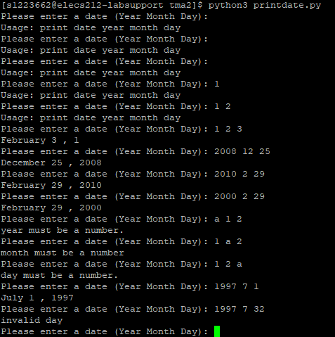

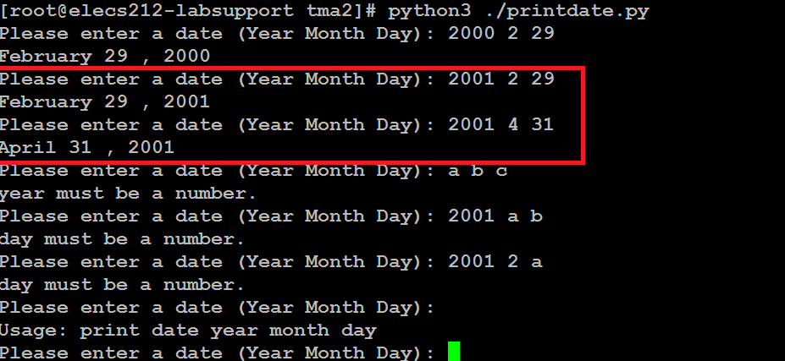

### Question 4 (25 marks)

#### Answer the following questions in your own words.

7 marks.

1. The question is talking about **TCP** connection, it is becauseclient needs to establish the channel and terminate it. This is a basic step for TCP socket connection.

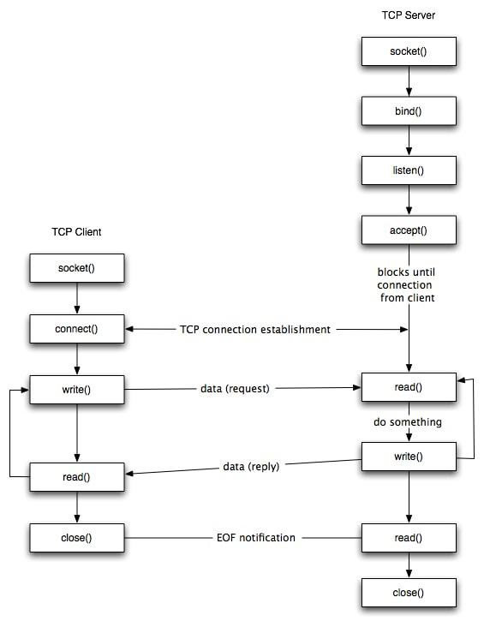

**Programming flow:**When application use TCP or UDP, it will be using the OS library, these libraries called API (Application Programming Interface).

When talking about TCP and UDP protocols, we identity client and server.

Socket is very interesting, can be used as a socket or slot. One end plugged into the client, one end is plugged into server, and then communicated. Therefore, before the communication, both must establish a socket.

After socket is created at both ends, TCP socket would be listening a port, called **bind**() function, which has a given ip address and port number.

When the server side has IP & port number, call **listen()** function.

When the function has been called, the server enters listening status. At this time, client can send the **connect()** function. If there is no any error, TCP connection is established.

In the kernel, two queues are maintained for each Socket. If three-way handshake success, server-side use **accept()** function.

After the connection is successfully established, client & server start to send**(read)** and receive**(write)** data.

This is the socket program function based on the TCP protocol.

??

5 marks.



**What is the function bind()?**Bind() means **t**he socket to a given IP address and port.

Why need ip address? Sometimes, a machine will have multiple network cards, and there is multiple IP address.   
  
**Why bind() is always required for both stream and datagram server but client side is NOT?**  
That means we can choose to listen to all the network cards or choose one. If choose one NIC, only the packet sent to this network card will be given.

For example, we write an application, when a network packet is coming to the kernel through 12345 port, TCP head inside to find the application, gave the packet to you.

In UDP status, the process is a bit different. UDP is connectionless, therefore, there is no need three-way handshake, it doesn’t need to call listen() & connect() function. However, UDP client & server interaction still needs IP address & port to identify each other. Therefore, it needs bind() function.

0.5 marks.



